AAF – ML in Finance
Marsel Miller
1. Introduction
The objective of this assignment is to implement a simplified Asset Allocation Forest (AAF) framework inspired by Bettencourt et al. (2024). The model uses macroeconomic state variables to identify market regimes and dynamically allocate capital across six asset classes: Equities, Bonds, Credits, Commodities, Gold, and High Yield bonds. The analysis evaluates whether machine learning based regime classification can improve portfolio allocation decisions relative to a passive benchmark.
2. Data and Preprocessing
The dataset contains 474 monthly observations spanning August 1983 through January 2023. Twenty-three state variables describe macroeconomic and financial market conditions, including inflation, credit spreads, equity volatility, term spreads, valuation measures, and financial conditions indices. Asset returns are available for six investable asset classes. A 15‑year expanding training window was selected, producing 180 initial training observations and 293 out‑of‑sample observations for evaluation.
3. Portfolio Optimization and Split Selection
For each node, portfolio weights were estimated using a maximum Sharpe ratio optimization procedure. Candidate splits were evaluated using improvements in portfolio Sharpe Ratios across resulting market regimes. Initial experiments identified CAPE, Inflation, TED spreads, and Credit Spreads as the most informative predictors. After extending the search across multiple candidate thresholds, Inflation emerged as the most informative root variable. A threshold of approximately 3.58% generated a substantial improvement in risk-adjusted performance, producing Sharpe Ratios of 0.507 and 0.356 in the resulting market regimes compared with 0.324 for the parent node.
4. Asset Allocation Forest Construction
A single allocation tree produced highly concentrated portfolios, often allocating the majority of capital to High Yield bonds. To reduce estimation variance, bootstrap aggregation was introduced through a Random Forest style framework. The final implementation averaged allocations across three bootstrap trees. Although a larger forest would normally be preferred, three trees were used to maintain computational feasibility during the expanding-window backtest. The resulting forest allocations were substantially more diversified, including meaningful exposure to Credits, Commodities, Equities, and Bonds.

5. Out-of-Sample Performance
The Asset Allocation Forest was evaluated using a fully out-of-sample expanding-window backtest from September 1998 to January 2023. At each rebalancing date, the model was estimated using only information available at that point in time and the resulting portfolio weights were applied to next-month returns. The strategy generated an annualized return of 6.35%, annualized volatility of 7.67%, a Sharpe Ratio of 0.83, and a maximum drawdown of 18.1%.
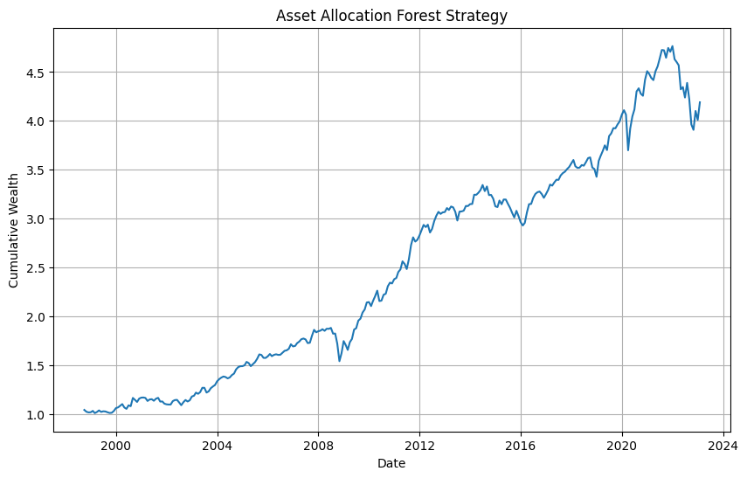
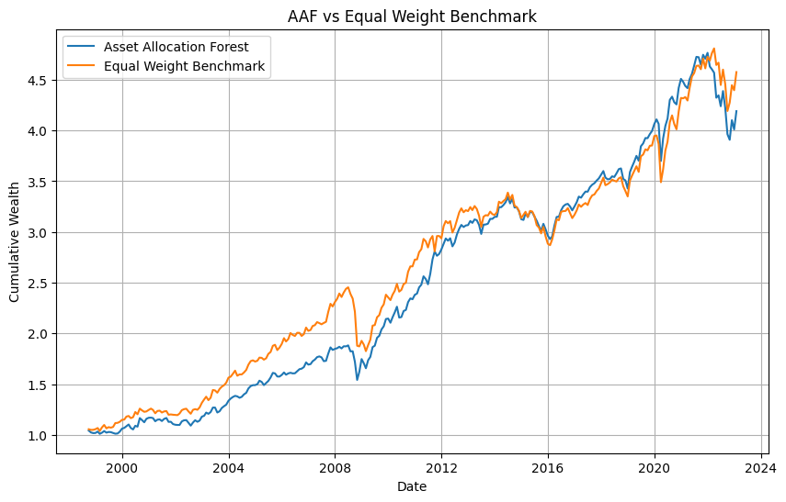
6. Benchmark Comparison and Discussion
The AAF strategy was compared with an equal‑weight benchmark portfolio. The benchmark achieved a slightly higher annualized return (6.78%) and a nearly identical Sharpe Ratio (0.83). However, the Asset Allocation Forest reduced annualized volatility and delivered a significantly smaller maximum drawdown (-18.1% versus -25.6%). The cumulative wealth paths of both strategies were similar, although the forest generally exhibited smoother behavior during periods of market stress.
Metric | AAF | Benchmark
Annual Return | 6.35% | 6.78%
Annual Volatility | 7.67% | 8.14%
Sharpe Ratio | 0.829 | 0.833
Maximum Drawdown | -18.1% | -25.6%

7. Conclusion
The results demonstrate that macroeconomic state variables contain useful information for dynamic asset allocation. The Asset Allocation Forest successfully identified economically meaningful market regimes and translated them into portfolio allocations. While the simplified three-tree implementation did not outperform the equal‑weight benchmark on return or Sharpe Ratio, it achieved lower volatility and materially improved downside protection. Because only three trees were used, the reported results should be viewed as a proof of concept. A larger forest would likely reduce estimation variance further and could potentially improve out‑of‑sample performance.

